Table of Contents
Group Info 3
Problem Statement 4
1. Setup and Installation Instructions 5
2. Data Acquisition and Exploratory Data Analysis 9
3. Experiment Tracking 11
4. Architecture Diagram 12
5. CI/CD Pipeline 13
6. Code Repository 15
7. Containerization and Deployment 15
8. Monitoring and Logging 15
9. Architecture Overview 17
10. Run using CURL/Postman API 18
11. Conclusion 19
Demo video 19

Heart Disease Prediction System – MLOps

Course | MLOps
Assignment | End-to-End MLOps Pipeline
Dataset | UCI Heart Disease Dataset
Group | Group 41
Repository | https://github.com/rahulvg/MLOPS-Assignment-Group-41-
Demo Video | Link

Group Info
Name | ID | Contribution
Abhay Kumar Mishra | 2024ab05080 | 100
Bharatam Sai Sachin | 2024AA05847 | 100
CHANDA RAKESH SANGANNA | 2024aa05747 | 100
Galgali Rahul VIthalrao | 2024AB05079 | 100
Tiyas Chatterjee | 2024AA05846 | 100

Problem Statement
The objective of this project is to design, develop, and deploy a scalable, reproducible, and production-ready machine learning system to predict the presence of heart disease based on patient health attributes.
The solution follows modern MLOps best practices, including experiment tracking, CI/CD automation, containerization, Kubernetes deployment, and monitoring.

1. Setup and Installation Instructions
1.1 Local Environment
Python Version: 3.10
Install Dependencies
pip install -r requirements.txt

Run Training File (Runs experiment with different parameter on Logistics Regression and Random Forest)
python train/train_experiment.py

Run all unit tests using Pytest
pytest

Create report using pytest
pytest --html=pytest_report.html

Launch MLflow UI (Local SQLite DB)
mlflow ui --backend-store-uri sqlite:///mlflow.db

Access MLflow at:
http://localhost:5000

1.2 Verification of Docker Build and Execution via GitHub Actions
Due to organizational restrictions that prevent local installation of Docker Desktop, the Docker image build and container execution were verified using GitHub Actions, which provides a Docker-enabled runner environment.
This ensures that containerization and execution are reproducible, verifiable, and independent of local system constraints.

- Navigate to the GitHub repository:
https://github.com/rahulvg/MLOPS-Assignment-Group-41-
- Click on the Actions tab in the repository.
- Select the most recent workflow run under the CI pipeline.
- Open the workflow run and inspect the following steps:
  - Build Docker image
This step executes the Docker build command using the project’s Dockerfile.
  - Run Docker container and test API
This step starts the container and invokes the /predict endpoint using a sample JSON request.

Evidence of Successful Docker Execution
Within the GitHub Actions workflow logs, the following evidence can be observed:
- Docker build logs confirming successful image creation
- Container startup logs indicating the FastAPI service is running
- Successful HTTP response from the /predict endpoint returning a prediction and confidence score

Screenshot of successful Docker run event
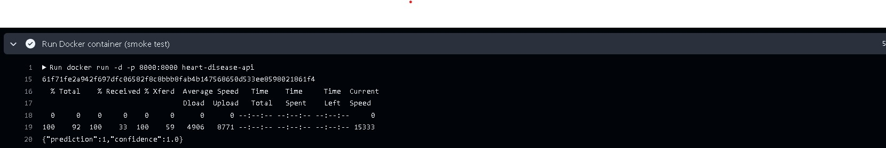

1.3 Kubernetes (Local Deployment with Minikube)
Start Minikube
minikube start --container-runtime=containerd

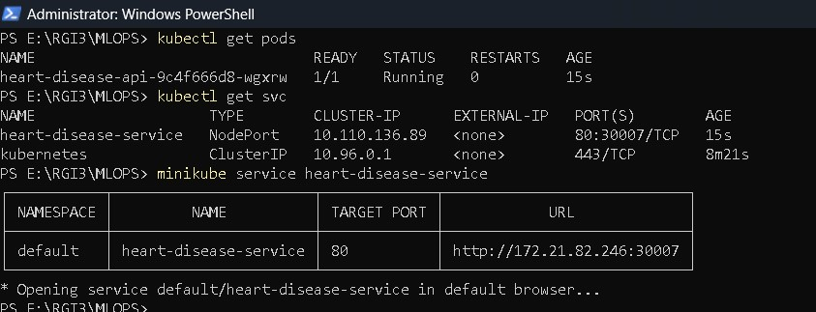

Inside Minikube
minikube image build -t heart-disease-api .
Deploy Application
kubectl apply -f k8s/deployment.yaml
kubectl apply -f k8s/service.yaml
Expose Service
minikube service heart-disease-service
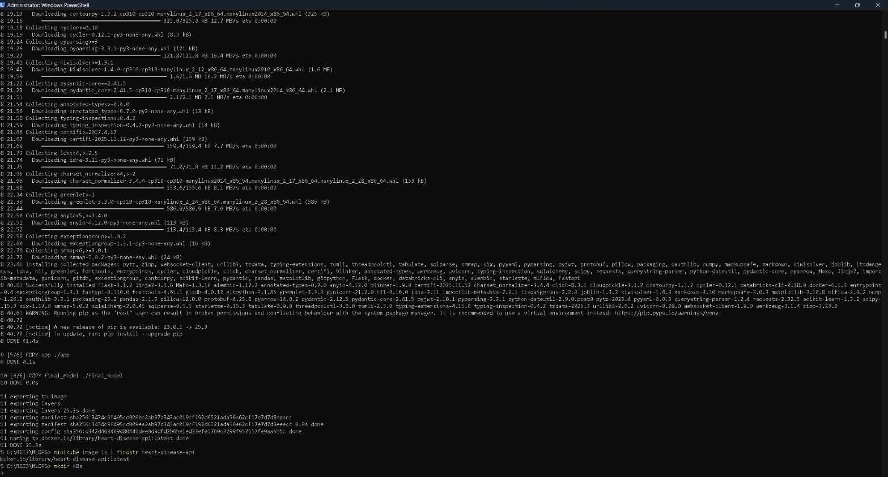

2. Data Acquisition and Exploratory Data Analysis
2.1 Dataset
- Source: UCI Machine Learning Repository
- Format: CSV
- Task: Binary classification (presence or absence of heart disease)
2.2 Preprocessing
- Missing values handled
- Numerical features scaled using StandardScaler
- Target variable encoded
- Preprocessing implemented using a scikit-learn Pipeline
2.3 Exploratory Data Analysis (EDA) & Modelling choice
- Feature distributions analyzed using histograms
- Correlation heatmap used to study feature relationships
- Class balance verified
The modelling approach was guided by dataset characteristics, interpretability needs, and deployment stability.
Two models were evaluated:
- Logistic Regression – chosen as a strong, interpretable baseline for structured medical data
- Random Forest – included to capture non-linear relationships and feature interactions
All numerical features were standardized using StandardScaler, and preprocessing was implemented through a unified scikit-learn Pipeline to ensure reproducibility, prevent data leakage, and enable deployment-safe inference.

Hyperparameter Tuning
- Logistic Regression: C ∈ {0.1, 1.0, 10.0}
- Random Forest:
  - n_estimators ∈ {100, 200}
  - max_depth ∈ {None, 10}
Each configuration was logged as a separate experiment using MLflow.

Evaluation
Models were evaluated using 5-fold cross-validation with the following metrics:
- Accuracy
- Precision
- Recall
- ROC-AUC

Final Model
Logistic Regression with C = 0.1 was selected due to:
- Consistent cross-validation performance
- Lower variance across folds
- Better generalization
- Simpler and more interpretable behavior
Its stability and ease of monitoring make it well-suited for a production-oriented MLOps pipeline.

3. Experiment Tracking
MLflow was integrated to track:
- Model parameters
- Cross-validation metrics
- Model artifacts
All experiments are logged under a dedicated MLflow experiment for easy comparison.
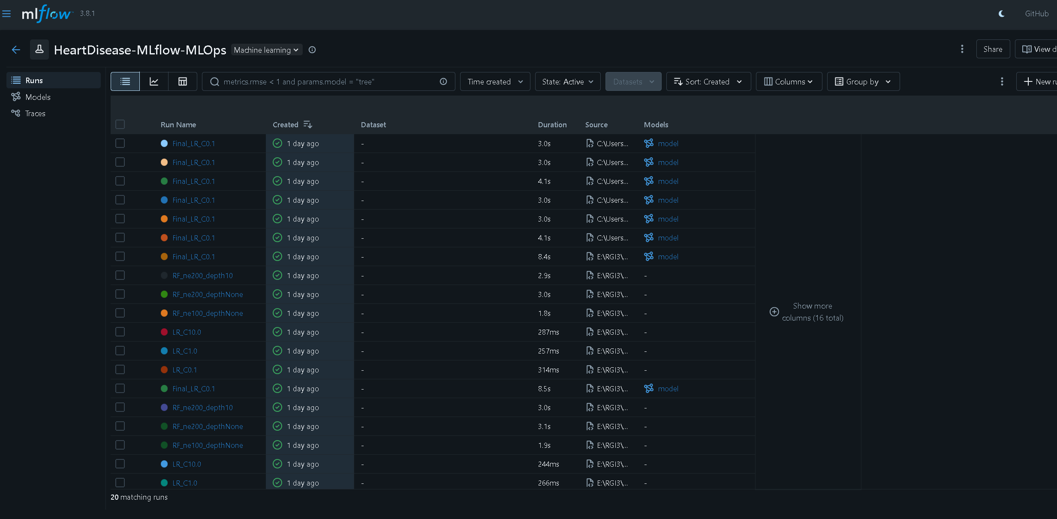
Model Packaging and Reproducibility
- Final model saved as a serialized scikit-learn Pipeline
- Model can be found at final_model\heart_disease_lr_c01.pkl in git repo.
- Preprocessing included within the model
- Reproducible inference guaranteed
- Dependencies listed in requirements.txt
- Artifacts stored and versioned using MLflow check mlflow_experiment.db in git repo

4. Architecture Diagram
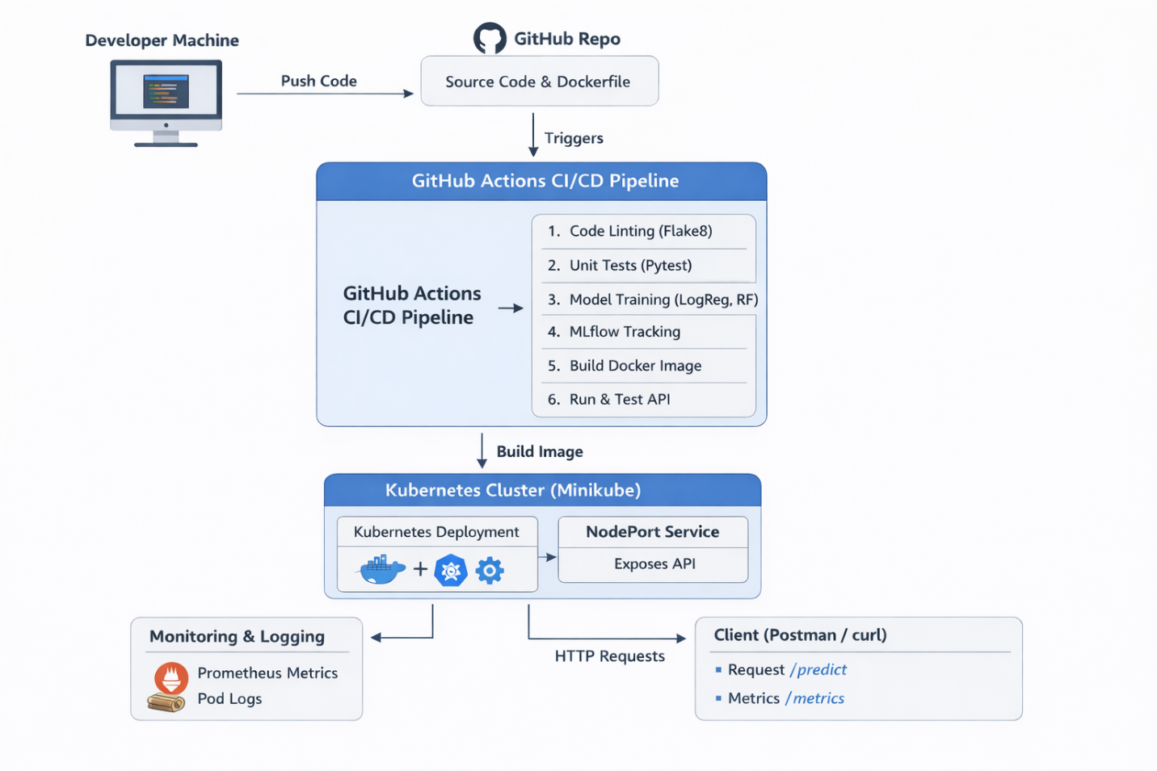

5. CI/CD Pipeline
Tools Used
- GitHub Actions
- Pytest
- Flake8
- Docker
Pipeline Stages
- Code linting
- Unit testing
- Model training
- Docker image build
- API smoke testing
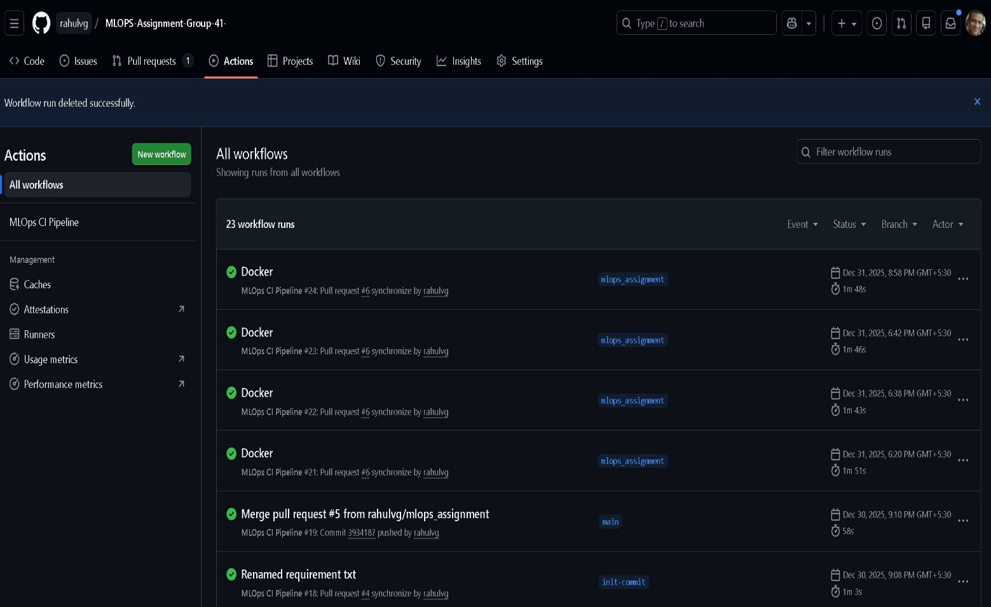

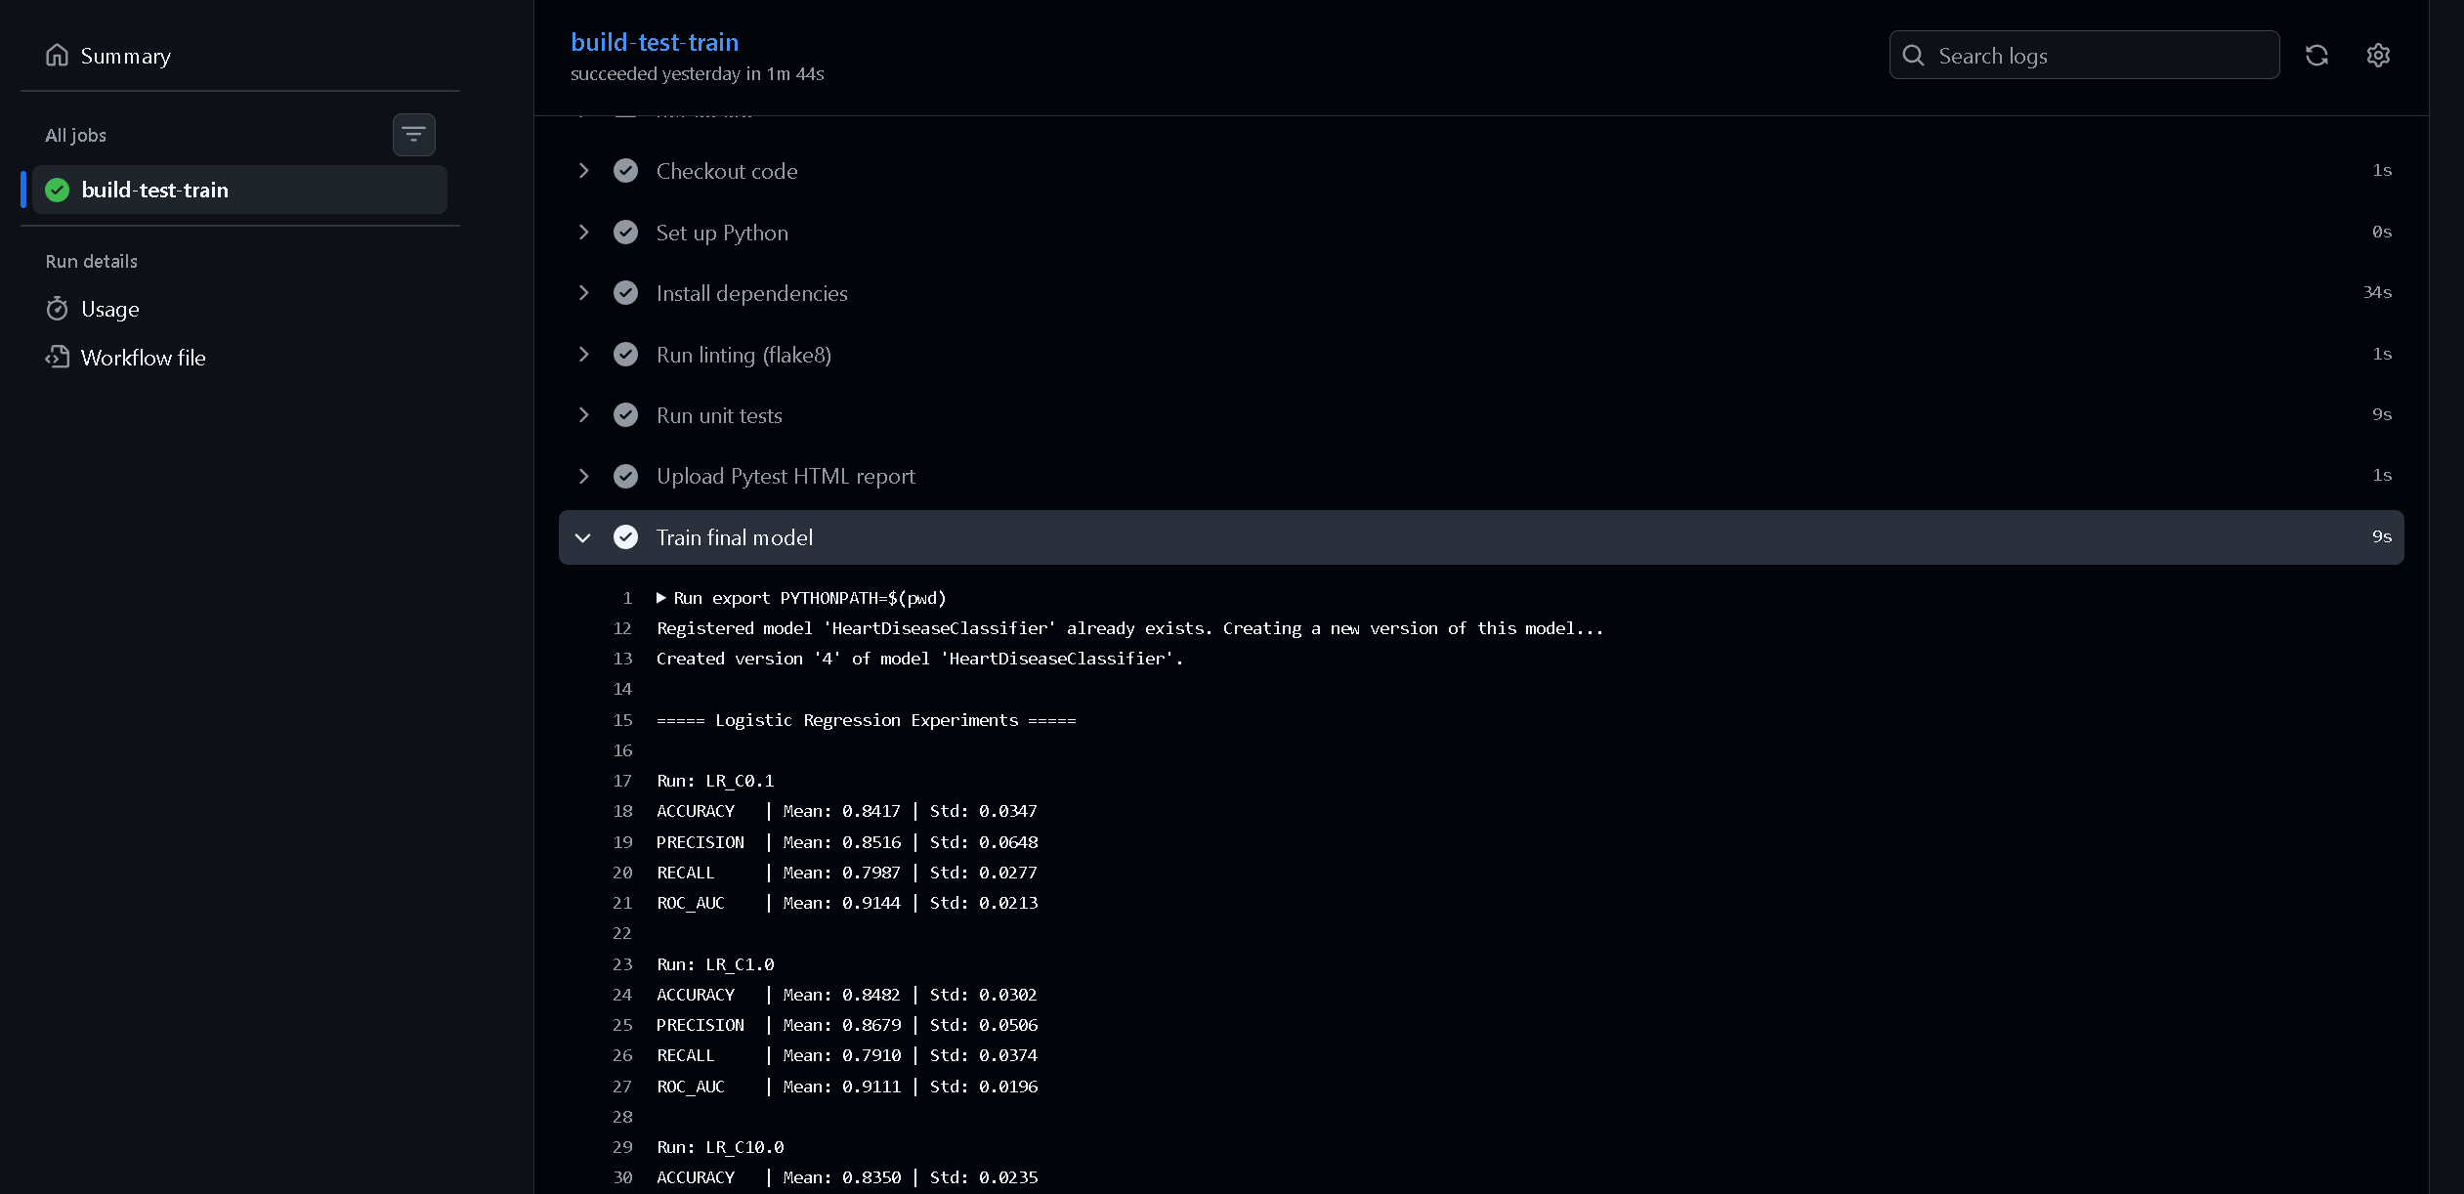

6. Code Repository
https://github.com/rahulvg/MLOPS-Assignment-Group-41-

7. Containerization and Deployment
7.1 Dockerized API
- FastAPI-based service
- /predict endpoint
- Accepts JSON input
- Returns prediction and confidence score
7.2 Kubernetes Deployment
- Local Kubernetes using Minikube
- Deployment and NodePort Service manifests
- API tested using curl and Postman

8. Monitoring and Logging
8.1 Logging
- Request-level logging implemented via FastAPI middleware
- Logs include endpoint, HTTP status, and latency
- Logs accessible via Kubernetes pod logs
8.2 Monitoring
- Prometheus-compatible /metrics endpoint exposed
- Metrics include request count and request latency
- Ready for Prometheus and Grafana integration

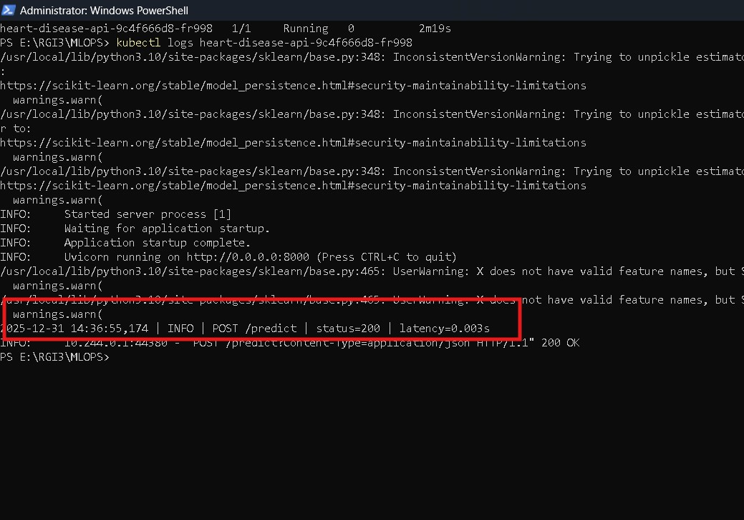

9. Architecture Overview
Client (Postman / curl)
→ FastAPI API (/predict, /metrics)
→ Scikit-learn Pipeline
→ Kubernetes Pod
→ NodePort Service
CI/CD is handled using GitHub Actions, and experiment tracking is handled using MLflow.

10. Run using CURL/Postman API
Curl Command
"curl -X POST http://127.0.0.1:30007/predict \
-H "Content-Type: application/json" \
-d '{"features":[63,1,145,233,1,0,150,0,2.3,0,0,1,0,0,1,0,0,1]}'"

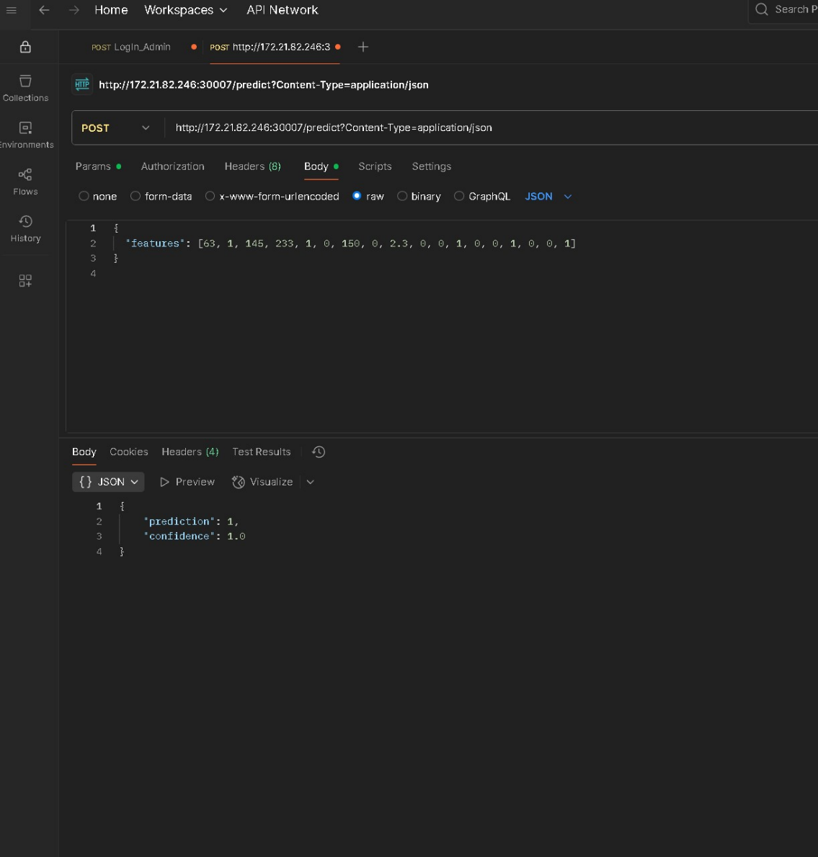

11. Conclusion
This project demonstrates a complete, production-grade MLOps workflow covering data analysis, model development, experiment tracking, CI/CD automation, containerization, Kubernetes deployment, and monitoring.
The system is scalable, reproducible, and aligned with real-world MLOps practices.

Demo video
Google Drive Link for Demo Video
Github Link for demo video

